**GP Global API Documentation**

Version: 1.2 (**Update**)

Created: 12 June, 2024

Updated: 02 July, 2024

Creation From

**B2M Technology**

Contents

1. Service List 3

2. Flowchart 3

3. Subscription,Un-Subscription 4

• Subscription API: 4

• Un-Subscription API: 4

4. Redirect Portal API 5

5. Notification API 5

6. Check Status 5

# 1. Service List

**Base URL**: [**https://gpglobal.b2mwap.com**](https://gpglobal.b2mwap.com)

* Goldenstream

|  |  |  |  |  |  |
| --- | --- | --- | --- | --- | --- |
| **#** | **Name** | **Type** | **Keyword** | **Validity** | **Charge** |
| 1 | Goldenstream - Daily | subscription | GSD | Daily | 3 tk |

# 2. Flowchart

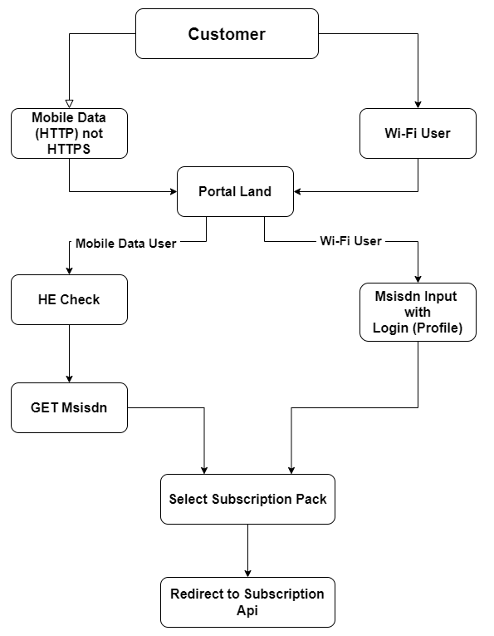

Fig: Basic Flow

# 3. Subscription,Un-Subscription

**Base URL**: <https://gpglobal.b2mwap.com>

## Subscription API:

You will redirect your request to This API for subscription with including MSISDN & service keyword as query string. Then, user will be get an OTP page from operator. After successfully match with user input OTP, then we will try to deduct balance from user MSISDN. Then B2M will redirect you with success/fail details in your redirect API. If you aren’t set success/fail URL, you will be redirect to your portal redirect API.

**Note:** You should use encode in **success URL** and **failed URL**;

|  |  |  |  |
| --- | --- | --- | --- |
| **End Point** | **API End Point URL** | **Method** | **Parameters** |
| Subscription | <**base_url**>/api/subscription | **GET** | * keyword * (required) * msisdn* (required) * success_url (optional) * failed_url (optional) |

**Response,**

|  |  |
| --- | --- |
| **Type/Action** | Go to Redirect Portal API |
| **Parameters** | msisdn = ******* |
| acr = ******* |
| type = subs |
| result = success/failed |
| **Example** | < **Redirect Portal API** >?msisdn=**&acr=**&type=subs&result= success/failed |

## Un-Subscription API:

You should send an http request to un-subscription API with required parameters by GET method and you will get a JSON response regarding in API response.

|  |  |  |  |
| --- | --- | --- | --- |
| **End Point** | **API End Point URL** | **Method** | **Parameters** |
| Un-Subscription | <**base_url**>/api/unsubscription | **GET** | keyword * (required), msisdn* (required), acr * (required) |

**Response,**

|  |  |
| --- | --- |
| **Type/Action** | JSON |
| **Response** | "**message**": "Unsubscribed successful", |

# 4. Redirect Portal API

This is partner API. Partner will be create this API for getting response of subscription. B2M will send notification/callback to partner via this API. You should ready this API with bellow format.

Example: < **Redirect Portal API** >?msisdn=**&acr=**&type=subs&result= success/failed

# 5. Notification API

This is notification API. Partner will be notify through this API for getting success/failed response of subscription. B2M will send notification to partner via this API. You should ready this API with bellow format.

**Note:** Status will be applicable only for subs, you should avoid status for “**type = renew**”;

Example:

< **Notification API**>?msisdn=**&keyword=**&acr=**&status=1/9&type=subs/renew&reason=ok/failed details &op_time=”2024-05-23 14:29:23”

# 6. Check Status

You should send an http request to check subscription with required parameters by GET method and you will get a JSON response regarding in API response.

|  |  |  |  |
| --- | --- | --- | --- |
| **End Point** | **API End Point URL** | **Method** | **Parameters** |
| Status Check | <**base_url**>/api/status-check | **GET** | keyword * (required), msisdn* (required), |

**Response,**

|  |  |
| --- | --- |
| **Type/Action** | JSON |
| **Response (for subs)** | "**msisdn**": "8801*********",  "**acr**": "OcCng****************",  "**status**": "Subscribed" |
| **Response (others)** | "**message**": "Subscriber not found" |